Robot Framework (Desktop Application Automation)

Topics:
- Libraries For Desktop Application Automation
- Robotframework-SikuliLibrary
a) Installation
b) Test Case Preparation
c) Demo Login App Test
- SikuliLibrary Keywords
- Automation Library For Windows OS

References:
https://robotframework.org/
https://github.com/rainmanwy/robotframework-SikuliLibrary#readme
http://sikulix.com/

Libraries For Desktop Application Automation:
1. ImageHorizonLibrary
2. SwingLibrary
3. TestFXLibrary
4. JavaFXLibraty
5. AutoItLibraty(COM Interface)
6. SikuliLibrary
7. WhiteLibraty

Robotframework-SikuliLibrary:
Installation:

Step 1: Install the basic components
Make sure you have at least java 8 installed, python 2.x or 3.x and pip.

Step 2: Install Robot Framework and Sikuli Library
Using pip, you can install Robot Framework
pip install robotframework
And then install the library
pip install robotframework-SikuliLibrary

Note:
- For Linux, there are some dependencies need be installed.
SikuliX internally uses OpenCV to support the image related features and Tesseract for the text features.
Go To This Link And Follow All Steps Carefully:
https://sikulix-2014.readthedocs.io/en/latest/basicinfo.html#sikulix-on-linux

Test Case Preparation:

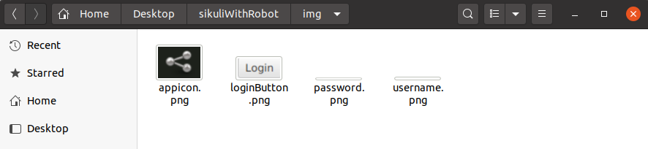

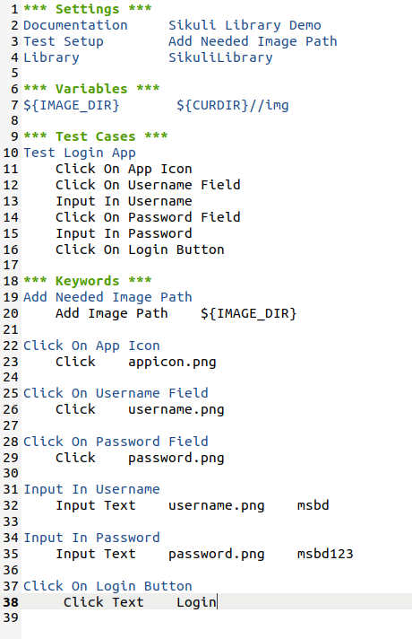

SikuliLibrary Keyword:
Add Image Path · Capture Region · Capture Roi · Capture Screen · Change Screen Id · Clear All Highlights · Clear Highlight · Click · Click In · Click Nth · Click Region · Click Text · Close Application · Double Click · Double Click In · Drag And Drop · Drag And Drop By Offset · Exists · Get Current Screen Id · Get Extended Region From · Get Image Coordinates · Get Match Score · Get Number Of Screens · Get Screen Coordinates · Get Text · Highlight · Highlight Region · Highlight Roi · Image Count · Input Text · Mouse Down · Mouse Move · Mouse Up · Open Application · Paste Text · Press Special Key · Read Text From Region · Remove Image Path · Reset Roi · Right Click · Right Click In · Screen Should Contain · Screen Should Not Contain · Select Region · Set Capture Folder · Set Capture Matched Image · Set Min Similarity · Set Move Mouse Delay · Set Ocr Text Read · Set Roi · Set Show Actions · Set Slow Motion Delay · Set Timeout · Set Wait Scan Rate · Start Sikuli Process · Stop Remote Server · Type With Modifiers · Wait For Image · Wait For Multiple Images · Wait Until Screen Contain · Wait Until Screen Not Contain · Wheel Down · Wheel Up
Automation Library For Windows OS:

WhiteLibraty

WhiteLibrary provides the means to automate Windows GUI technologies with Robot Framework. WhiteLibrary wraps the White automation framework.
Supported technologies include:
- Win32
- WinForms
- WPF (Windows Presentation Foundation)
- SWT (Java) platforms
Item Locators:
Prefix | Description
id (or no prefix) | Search by AutomationID.
text | Search by exact item text or name.
index | Search by item index.
help_text | Search by HelpTextProperty.
class_name | Search by class name.
control_type | Search by control type.

Workflow example
***Variables***
${TEST APPLICATION} | C:/path/to/my_application.exe
***Settings***
Library | WhiteLibrary
***Test Cases***
Small Example
 | Launch Application | ${TEST APPLICATION}
 | Attach Window | Window Title
 | Button Text Should Be | my_button | press this button
 | Click Button | my_button
 | Close Application

GUI Inspection:
- FlaUInspect
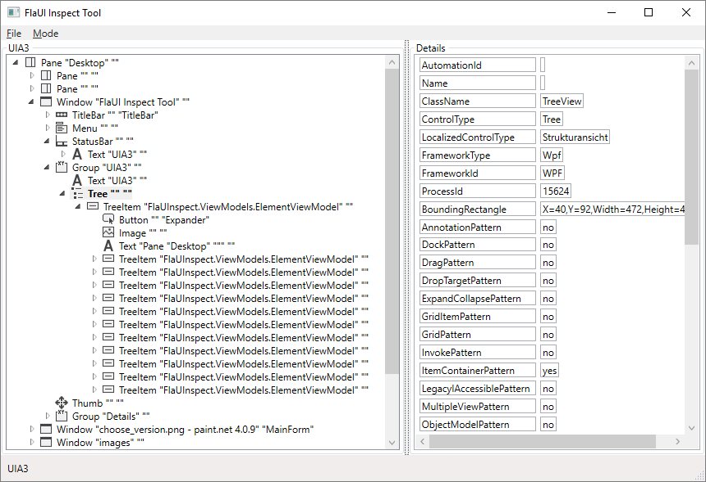

Robotframework-FlaUI Library
Robotframework-FlaUI is a keyword based user interface automation testing library for Windows applications like Win32, WinForms, WPF or Store Apps.

